Intermediate R

**Comparison Operators**

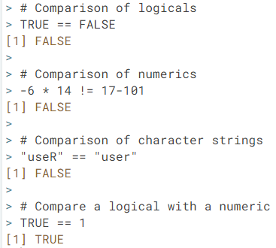

**Note**: in R, TRUE coerces to 1 and FALSE to 0. Also when comparing character strings, R uses alphabetical order to test greater/less than comparisons.

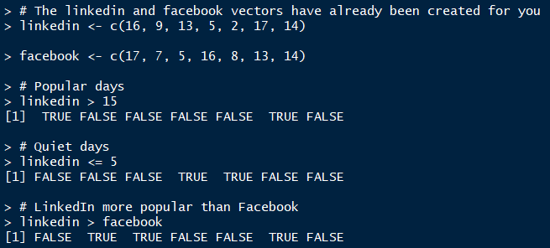

**vectors**

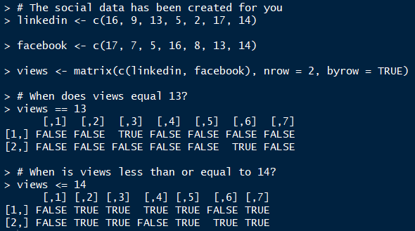

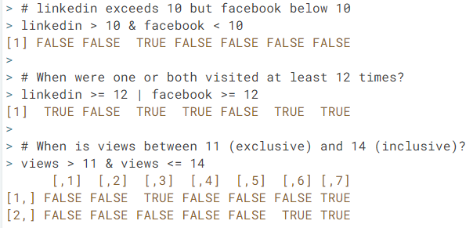

**matrices**

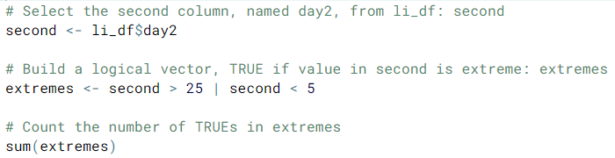

**a good way to count how many elements meet a given condition**

**Conditional Statements**

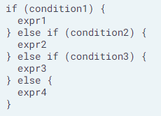

**While Loop**

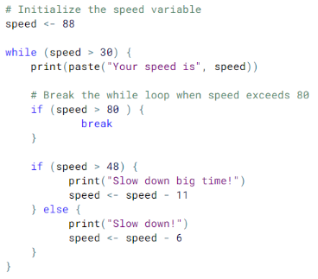

**notice the break statement**

**increment / decrement is CRITICAL in a While Loop**

**For Loop**

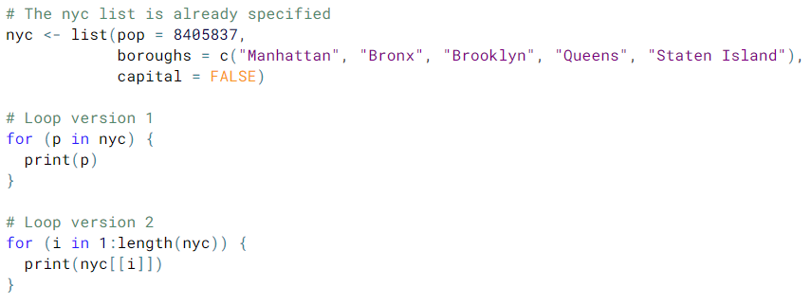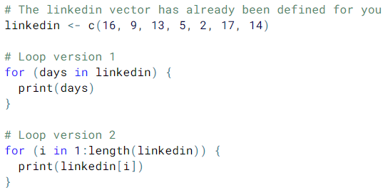

**iterating over a list**

**iterating over a vector**

**iterating over a matrix using a nested for loop**

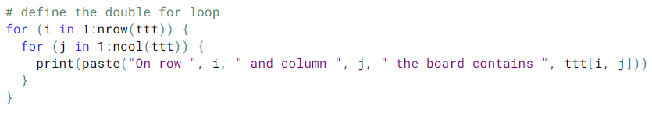



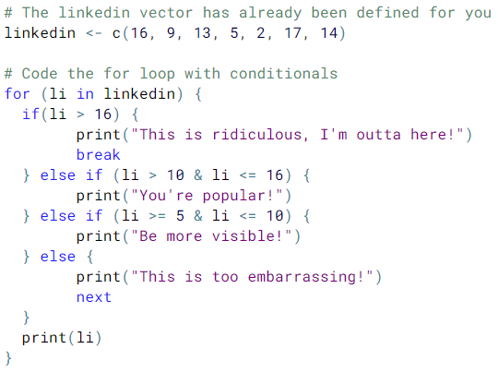

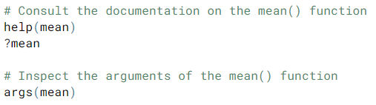**Functions**

Getting help with a function 🡺

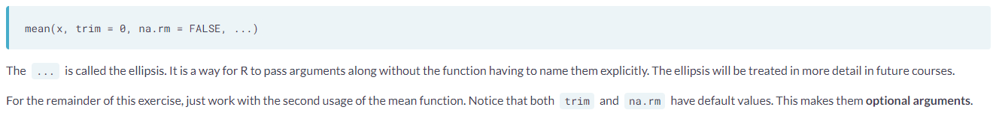

Key concepts regarding functions: 1) passing arguments, 2) argument default values, 3) passing arguments by position versus name, 4) variable scoping, 5) functions from packages.

**The apply Family**

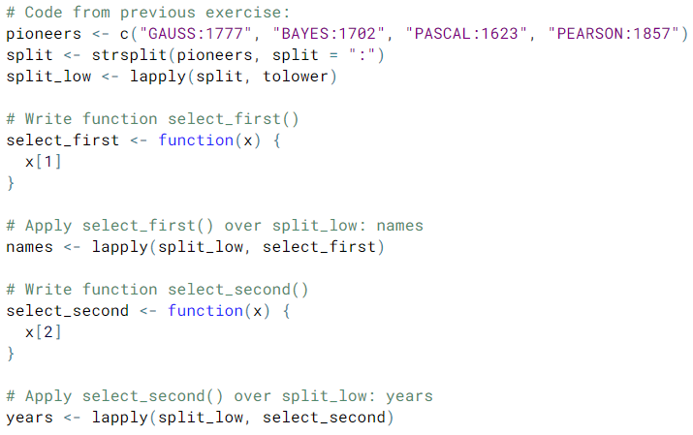

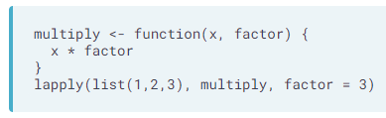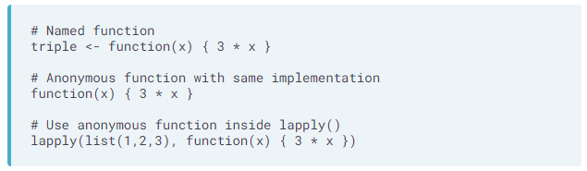**lapply** takes a vector or list X and applies the function FUN to each of its members. If FUN requires additional arguments, you pass them after you’ve specified X and FUN. The output of lapply() is a list, the same length as X, where each element is the result of apply FUN on the corresponding element of X.

install.packages()  
library()  
search()

